ReadMe file for TISB Hacks 2024

- Vedanth Prakash TISB Grade 8E

### What does my code do?

My code helps with identifying people at risk of developing diabetes based on input values such as Age, Gender, Blood glucose, and some other information. My current code has an accuracy of 95.99%! This is extremely good but has scope for improvement.

### How to run the code?

To run my code, you have to follow these steps. Images have been provided to assist you. You may also refer to this explanation [video](https://www.youtube.com/watch?v=8YqXo-ztkxo), which would provide some assistance in running my code.

<https://www.youtube.com/watch?v=8YqXo-ztkxo>

1. Download the “Main_Diabeties_predictor.csv”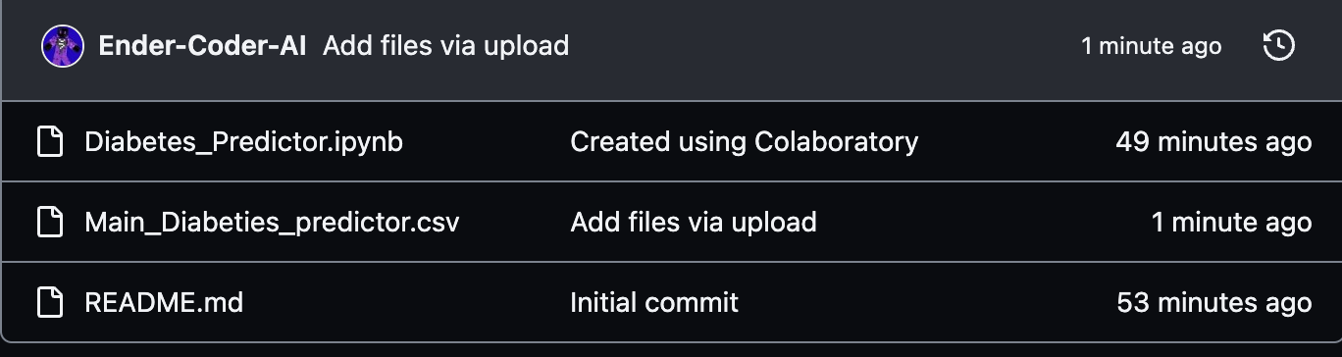

2. Open the “Diabetes_Predictor.ipynb”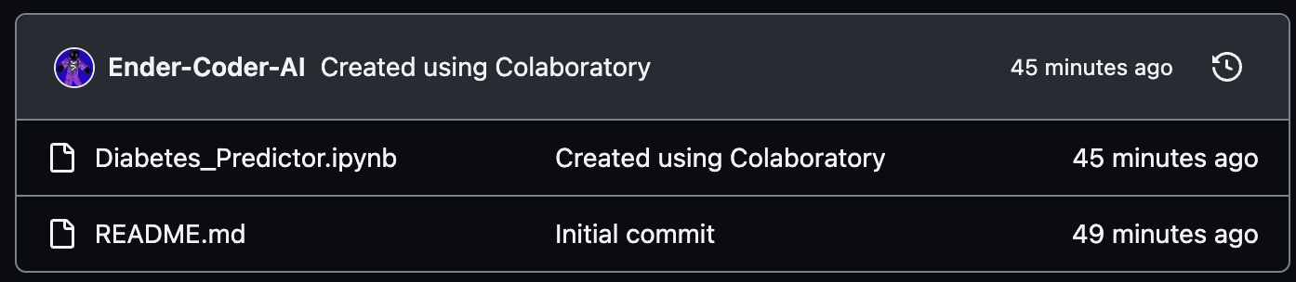

3. Next, click on the “Open in Colab” button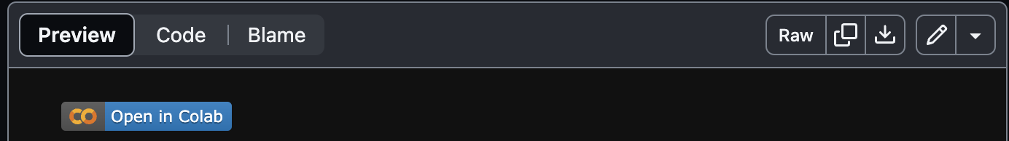

4. Drag and drop the downloaded file into the “files section” on the collaboratory notebook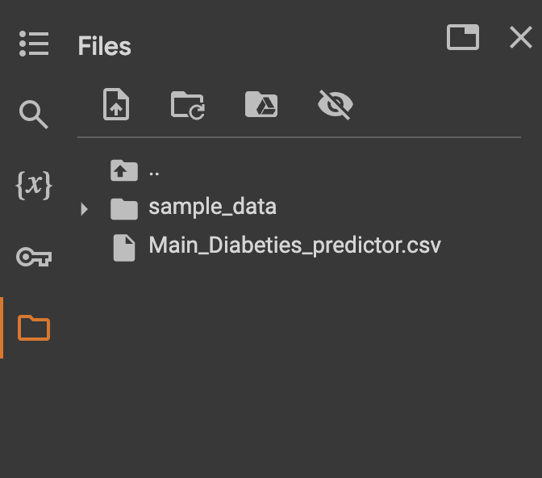

5. Run all the cells except the last one by clicking on the play button at the top left corner and wait for the green tick before running the next cell. Instructions for the last cell are provided later in this document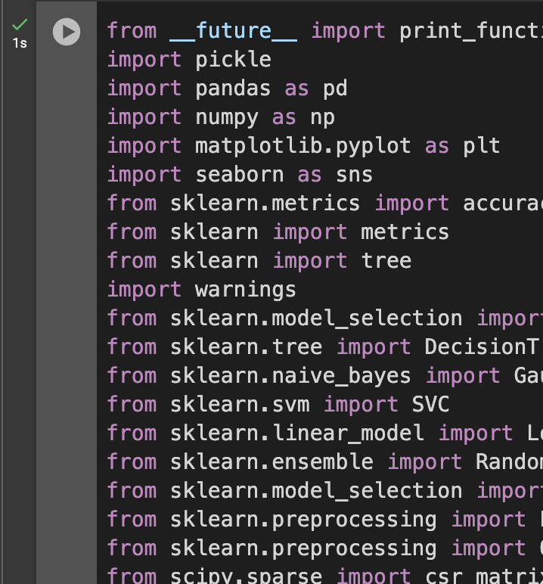

6. Note how a few new files appear under the “files” section, this may take a while.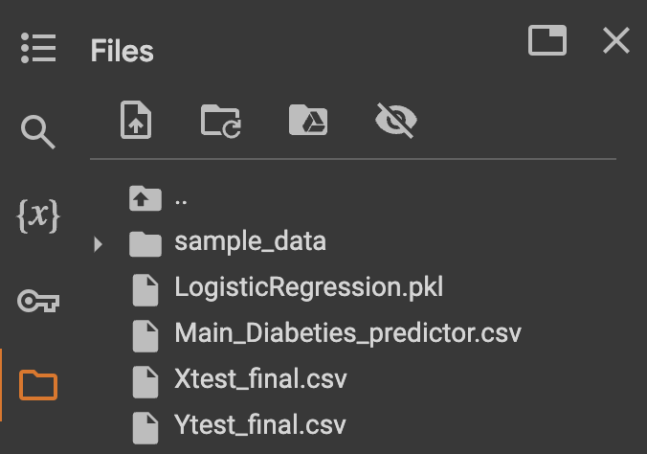

7. Open the “Xtest_final.csv” and the “Ytest_final.csv” by double clicking on them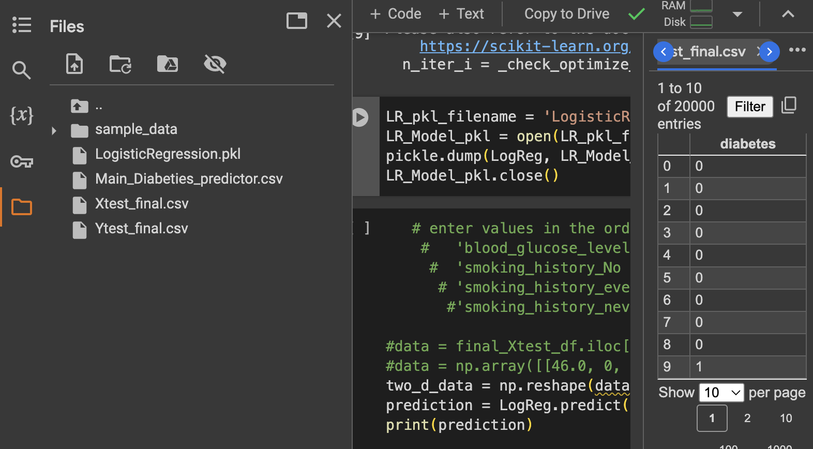

8. You can run a prediction in 2 ways. Firstly, you can uncomment the first “data” line and input a row number in the square brackets with reference to a row number on the “Xtest_final.csv” which you can see on the panel on the right, and then run the cell. The output would be 1 or 0. To check your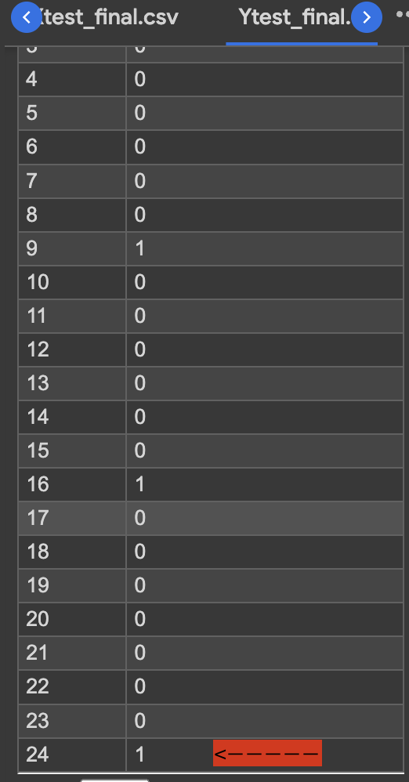 answer, find the same row number on the “Ytest_final.csv” and find the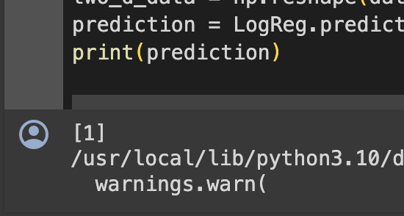 output. (1 = risk of diabetes) (0 = no risk)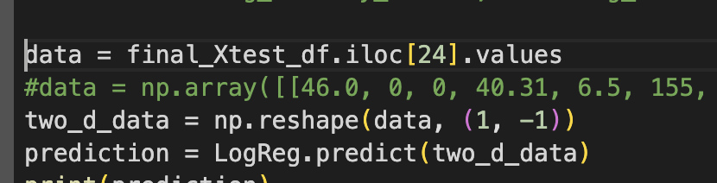

9. The second way is to comment the first “data” line and uncomment the second “data” line. For this method, you can input your values in the order at the top of the cell. You may refer to the cheat sheet below to input your values. The output value will still be the same (1 or 0)

“Binary” indicates that you must input a 1 or 0 where 1 = yes/present and 0 = no/absent.

Age = 1.0 to 120.0

Hypertension = Binary

heart_disease = Binary

Bmi = 10.0 - 100.0

HbA1c_level = 3.5 - 9.0

Blood_glucose_level = 70.0 - 300.0

gender_female = Binary

gender_male = Binary

gender_other = Binary

smoking_history_No Info = Binary

smoking_history_current = Binary

smoking_history_ever = Binary

smoking_history_former = Binary

smoking_history_never = Binary

smoking_history_not current = Binary

**IMPORTANT NOTES!!**

1. **For “gender” and “smoking_history,” only one subcategory (like “gender_male” or “smoking_history_never”) may have a value of 1, and the rest must have a value of 0.**
2. **For all non-binary inputs, you must add a decimal point followed by a number, even if it is 0, for example (23.0 or 23.4 or 0.0)**
3. **All the input values must follow the order shown in the cell for the correct output.**

